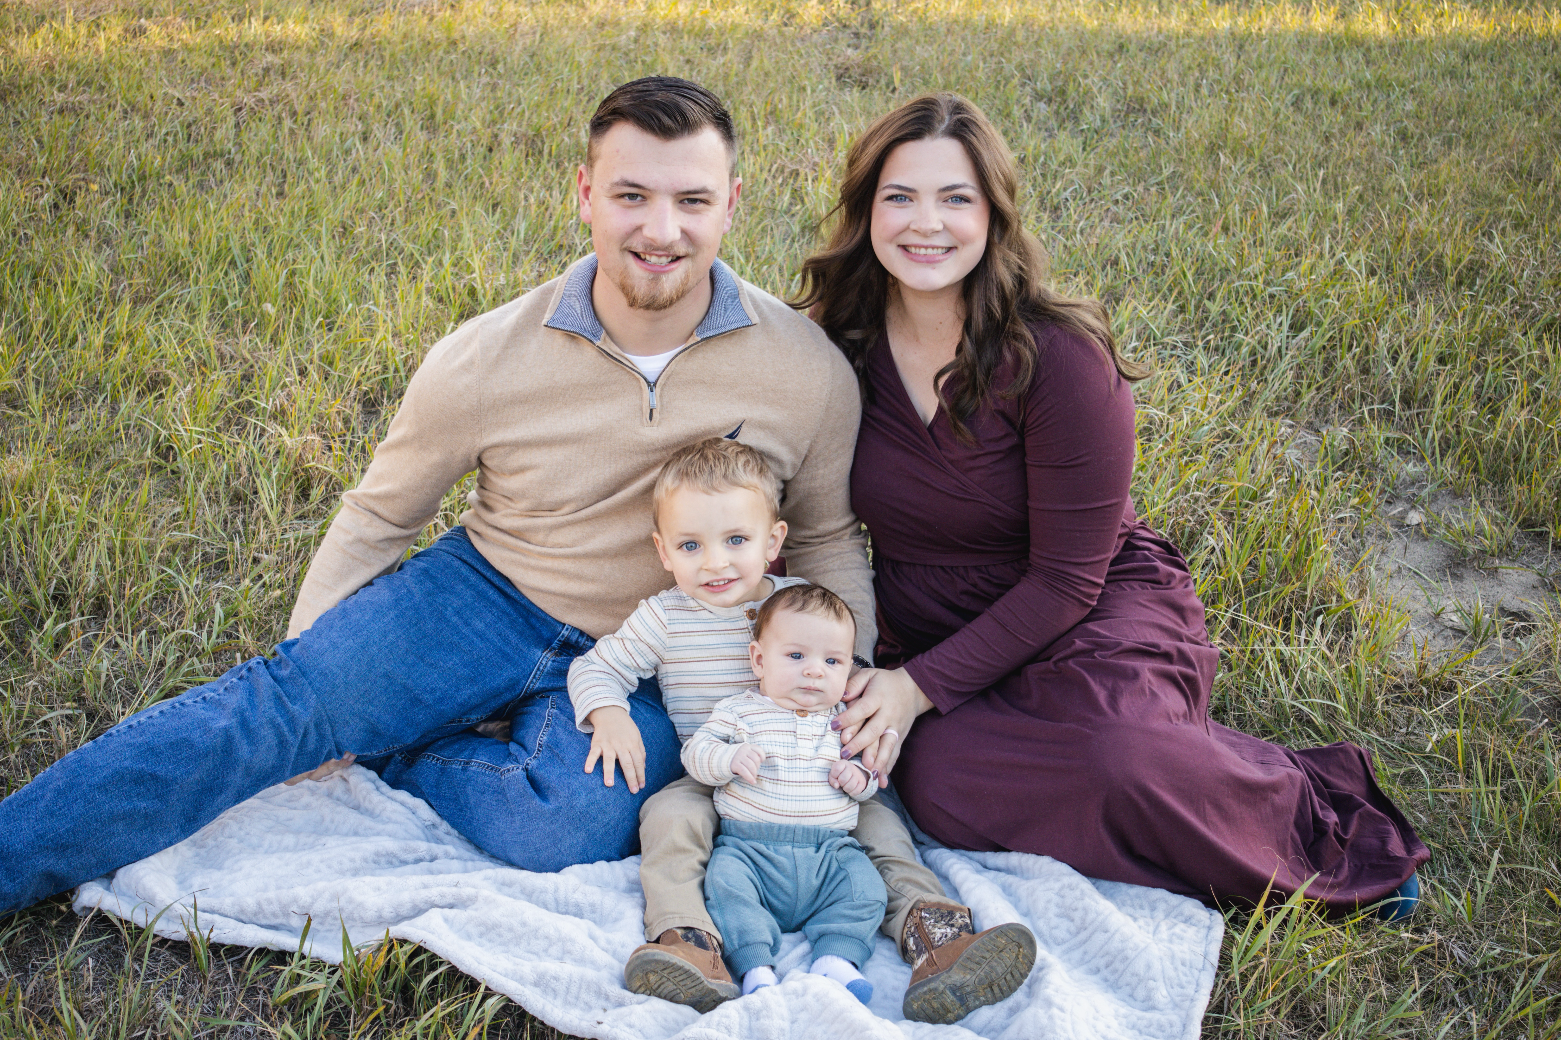
THE SKOGEN FAMILY
CHURCH PLANTERS
FIRST BAPTIST CHURCH

S T . J A M E S , M I N N E S O T A

Hello, Praying Friends and Churches!

Happy New Year! God has officially brought us through our first year of ministry here in St. James! It has been amazing to see how the Lord has been working in St. James and the surrounding community.
We have had a very busy last six months. We started the fall by welcoming our second son, Aleksander Duane who was born on September 9th. Both mom and baby are healthy and baby is growing well.
God has allowed us to become involved in several different areas of our community. The Mayor of St. James got saved over the summer and he and his family now attend our church. This has opened the door for Liam to become involved in the political scene in St. James. Also, there was an opening on the Volunteer Fire Department in town and Liam was able to get on board. This puts us in contact with many of the First Responders and core individuals in our area which has allowed us to be a witness and help to them.
We kicked off the fall in church with starting our first children’s Sunday School class!
We hosted “Harvest Sunday” in celebration of Thanksgiving and had our largest attendance yet with 29 in church! The Lord has blessed, and we have seen our attendance rise to about 17 in attendance on average.
We held our first Christmas Eve service and had 22 with an amazing 11 visitors and 1 salvation! It was a blessing to see our people's prayers answered as many of them had family that they were praying would come and they did!
We had a total of 68 first time visitors and 15 salvations in 2025! We are so excited to continue serving here is St James in 2026!
We are specifically praying for a church van in 2026 as we seek to reach even more in our community who need help with transportation. We currently pick up individuals in our own vehicle but are not able to promote and offer transportation to everyone because we have reached our limit.
2026 has started off strong as we have seen 14 different visitors as of this past Sunday and 2 salvations!
We thank you so much for your prayers and support!

God Bless,
The Skogen Family

